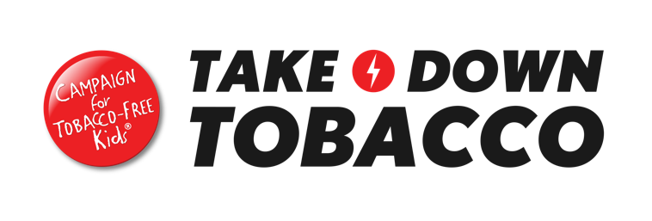
Take Down Tobacco
National Day of Action 2026
Youth Social Media Promotion Toolkit
Background
Thank you for helping to spread the word about Take Down Tobacco National Day of Action on April 1, 2026!
We’re so excited to see how young people and advocates around the country rally together to stand up to Big Tobacco.
This social media toolkit contains template language to help get the word out about the Day of Action. In addition to these posts promoting the Day of Action at-large, we encourage you to get the word out about events happening in your community.
Guidelines
- Please feel free to use the suggested language or edit
- You are welcome add your organization’s logo to the graphics, but please do not remove the Take Down Tobacco logos or make other edits to the provided graphics
- Please tag Take Down Tobacco (handles below) or use the hashtag: #TakeDownTobacco when posting
Take Down Tobacco Social Media Channels
Please follow Take Down Tobacco’s social media channels:
Facebook
Instagram
Twitter
TikTok
Please follow Campaign for Tobacco-Free Kids’ social media channels:
Facebook
Instagram
Twitter
LinkedIn

Option 1: Are You Ready?
Ready to call out Big Tobacco? 👀
On April 1, young people across the country are stepping up and speaking out. The tobacco industry targets our generation to protect its profits — and we’re not having it.
This is our moment. Take action. Make noise. Demand change.
Join us: TAKEDOWNTOBACCO.ORG
#TakeDownTobacco
Option 2: Don’t Let Big Tobacco Trap You
Fun flavors. Real consequences.
Big Tobacco uses candy and fruit flavors to make addiction look harmless. It’s not. Flavors are designed to hook us early and keep us hooked.
We deserve better than being Big Tobacco’s next customer.
On April 1, stand with youth across the country and demand an end to flavored tobacco. #TakeDownTobacco
Option 3: National Day of Action
April 1 = National Day of Action.
Big Tobacco is still trying to hook a new generation with slick marketing and flavored products. We see the tricks — and we’re exposing them.
Young people aren’t targets. We’re leaders. And we’re pushing for real change in our communities.
Show up. Speak out. #TakeDownTobacco

Social graphics
Option 1
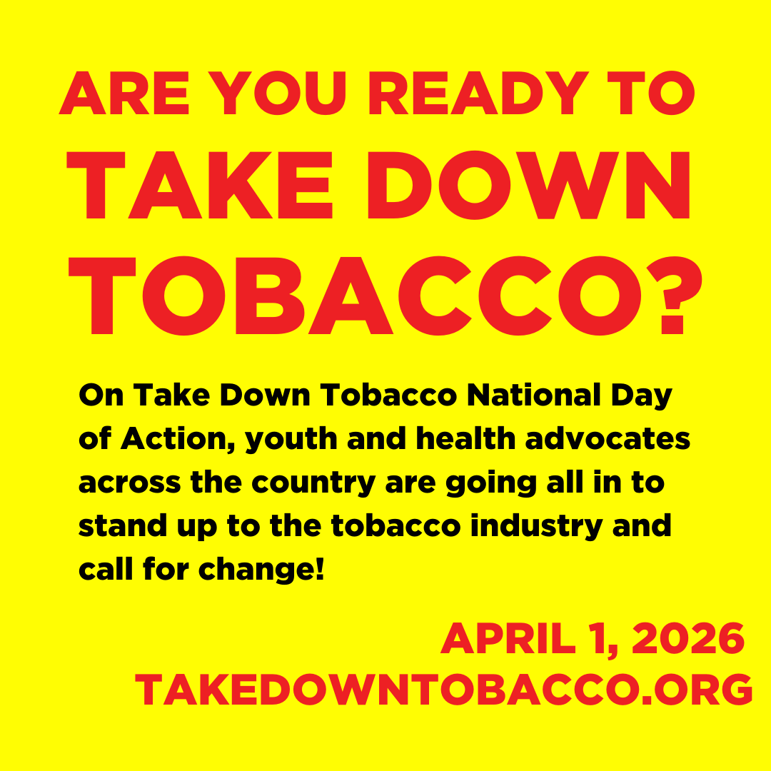
Option 2
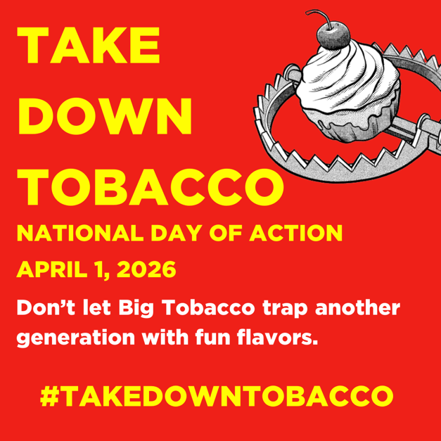
Option 3

